Kitty Toy Box
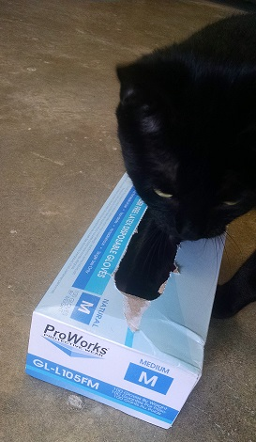
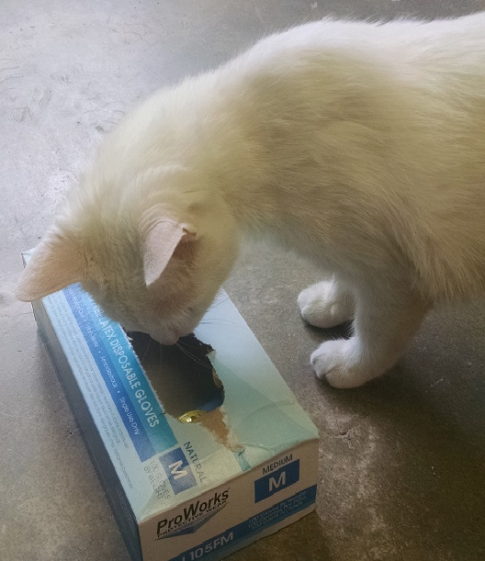
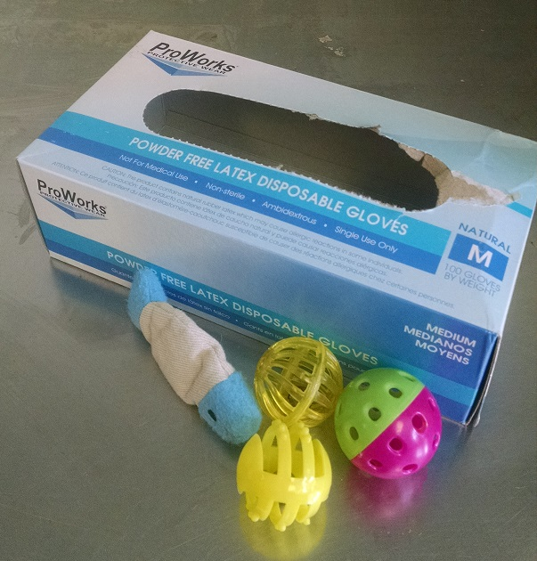

- Gather various types of toys including plastic balls, catnip toys and small stuffed toys
- Find a small box that will contain the toys and fit inside of the cage such as a tissue box, food box or tissue box
- Gently shake box to peak kitty’s interest
- Place on flat surface and allow kitty to enjoy investigating

