ICE CUBE
DILUTE BOUILLON CUBE WITH TWICE THE AMOUNT OF WATER REQUIRED

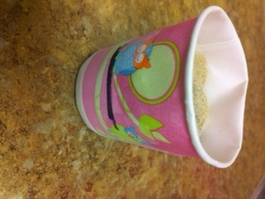
FILL BROTH MIXTURE TO APROX ¼ THE WAY FULL (SEE LINE ON CUP)

REMOVE PAPER FROM ICECUBE
AND SERVE TO DOG (ITS OK FOR A PIECE FROM THE BOTTOM TO REMAIN ON ICE BLOCK