Hand Feeding
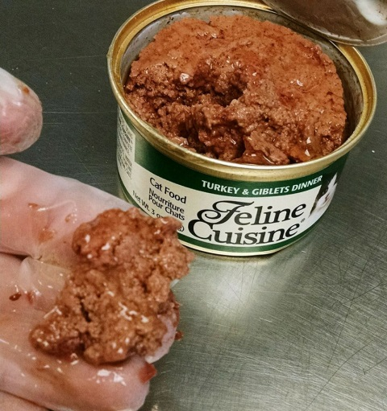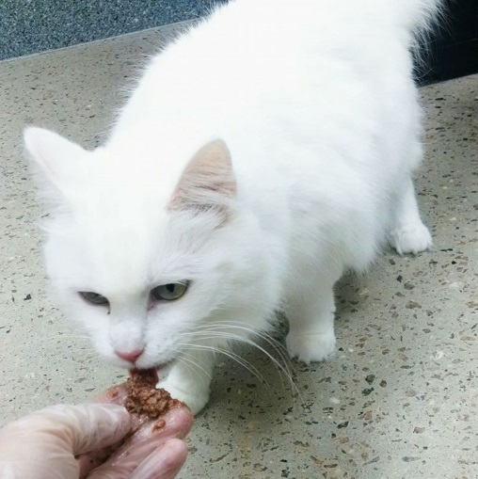
- Gather supplies
  - Small can of canned food
  - Gloves
- Either sit quietly on floor or stand (if in caged room), take a small amount of canned food and hold out for kitty
- Stand/sit with your body angled away from the cage/cat,
- Use soft eyes to look at kitty, do not stare or face directly unless cat approaches you this way
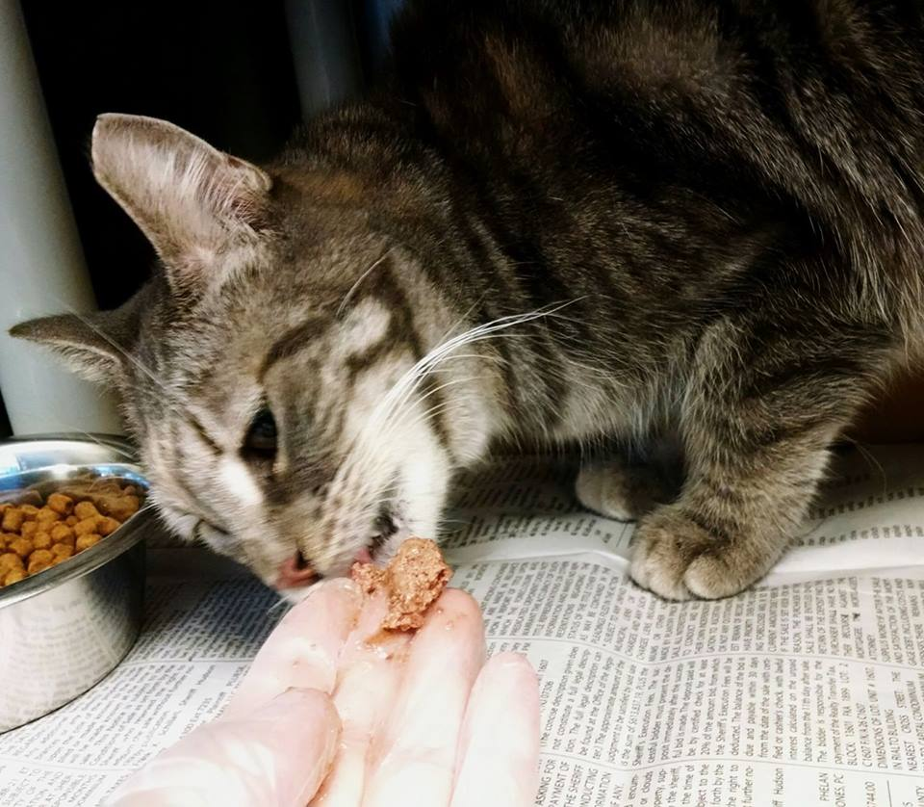
- If cat is hesitant, you can drop tiny bits of food in front of them to see their comfort zone
